Chapter 10, Problem 37.

Use mesh analysis to find currents I₁, I₂, and I₃ in the circuit in Fig. 10.82

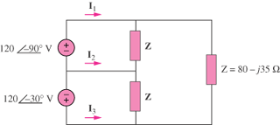

Figure 10.82
For Prob. 10.37.

